Web Technologies Project 1

Screenshots:

1.) Html validation

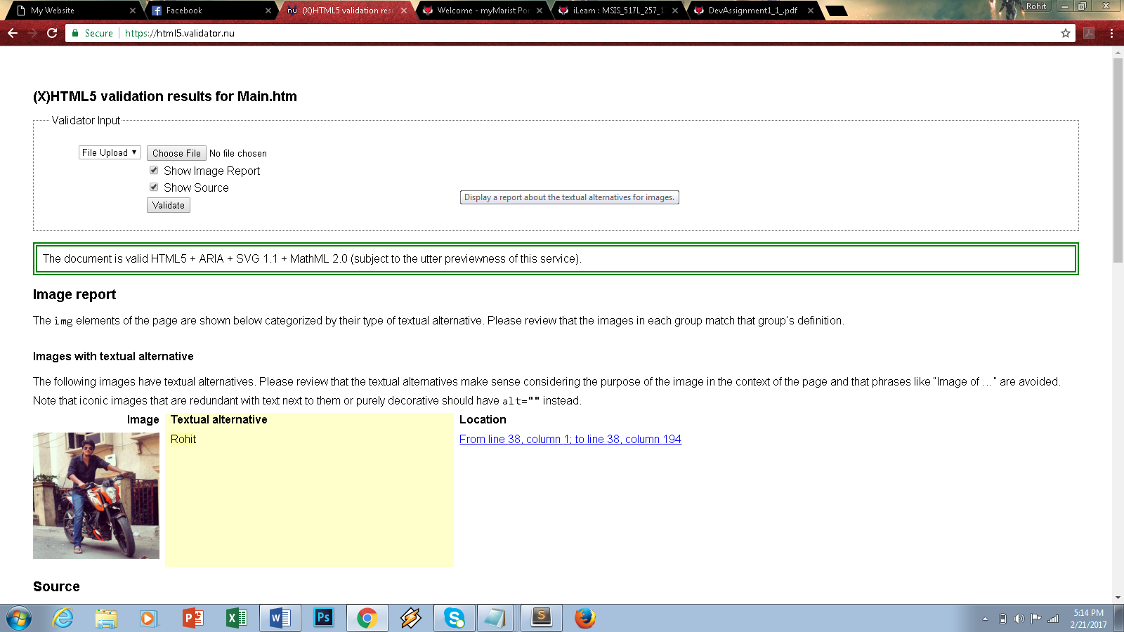

2.) CSS file

